import pandas as pd
import numpy as np
import matplotlib.pyplot as plt

df = pd.read_csv('sales_data.csv')

print(df.head())

print(df.isnull().sum())

df['Sales'].fillna(df['Sales'].mean(), inplace=True)
df.dropna(subset=['Product', 'Quantity', 'Region'], inplace=True)

print(df.describe())

product_summary = df.groupby('Product').agg({
'Sales': 'sum',
'Quantity': 'sum'
}).reset_index()
print(product_summary)

11

plt.figure(figsize=(10, 6))
plt.bar(product_summary['Product'], product_summary['Sales'])
plt.xlabel('Product')
plt.ylabel('Total Sales')
plt.title('Total Sales by Product')
plt.show()

df['Date'] = pd.to_datetime(df['Date'])
sales_over_time = df.groupby('Date').agg({'Sales': 'sum'}).reset_index()
plt.figure(figsize=(10, 6))
plt.plot(sales_over_time['Date'],sales_over_time['Sales'])
plt.xlabel('Date')
plt.ylabel('Total Sales')
plt.title('SalesOver Time')
plt.show()

pivot_table = df.pivot_table(values='Sales', index='Region', columns='Product',
aggfunc=np.sum, fill_value=0)
print(pivot_table)

correlation_matrix = df.corr(numeric_only=True)
print(correlation_matrix)

import seaborn as sns
plt.figure(figsize=(8, 6))
sns.heatmap(correlation_matrix, annot=True, cmap='coolwarm')
plt.title('Correlation Matrix')

OUTPUT

Date Product Sales Quantity Region
0 2023-01-01 Product A 200 4 North
1 2023-01-02 Product B 150 3 South
2 2023-01-03 Product A 220 5 North
3 2023-01-04 Product C 300 6 East
4 2023-01-05 Product B 180 4 West
Date 0
Product 0
Sales 0
Quantity 0
Region 0
dtype: int64
Sales Quantity
count 16.000000 16.000000
mean 237.500000 5.375000
std 49.598387 1.454877
min 150.000000 3.000000
25% 207.500000 5.000000
50% 220.000000 5.000000
75% 277.500000 5.250000
max 320.000000 8.000000
Product Sales Quantity
0 Product A 1350 33
1 Product B 850 17
2 Product C 1600 36

/tmp/ipykernel_7773/2000942776.py:11: FutureWarning: A value is trying to be set on a copy of a DataFrame or Series through chained assignment using an inplace method.
The behavior will change in pandas 3.0. This inplace method will never work because the intermediate object on which we are setting values always behaves as a copy.

For example, when doing 'df[col].method(value, inplace=True)', try using 'df.method({col: value}, inplace=True)' or df[col] = df[col].method(value) instead, to perform the operation inplace on the original object.

df['Sales'].fillna(df['Sales'].mean(), inplace=True)

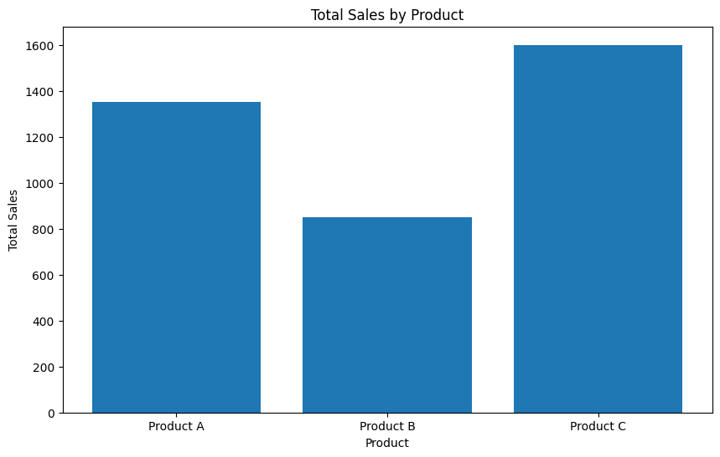
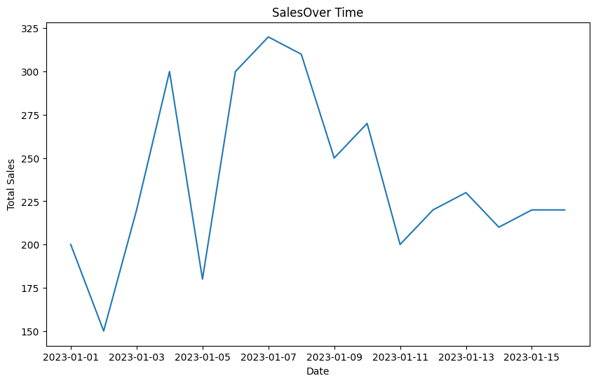
/tmp/ipykernel_7773/2000942776.py:40: FutureWarning: The provided callable <function sum at 0x7ff489df4ea0> is currently using DataFrameGroupBy.sum. In a future version of pandas, the provided callable will be used directly. To keep current behavior pass the string "sum" instead.
pivot_table = df.pivot_table(values='Sales', index='Region', columns='Product',

Product Product A Product B Product C
Region
East 310 0 740
North 720 0 410
South 320 420 220
West 0 430 230
Sales Quantity
Sales 1.000000 0.910021
Quantity 0.910021 1.000000

